Project Design Phase-II
Data Flow Diagram & User Stories

Date | 25-09-2026
Team ID | SWTID-2026-2919
Project Name | AI FitTrack
Maximum Marks | 4 Marks

Project Design Phase-II

Data Flow Diagram & User Stories

Data Flow Diagrams
A Data Flow Diagram (DFD) represents how data moves through the AI FitTrack system. It shows how users interact with the backend, how requests are processed, how data is stored in MongoDB Atlas, and how AI requests are sent to Google Gemini.

Level 0 – Context Diagram
External Entity: User / API Client
Process: AI FitTrack System
Data Store: MongoDB Atlas
External Service: Google Gemini AI

Main Data Flow

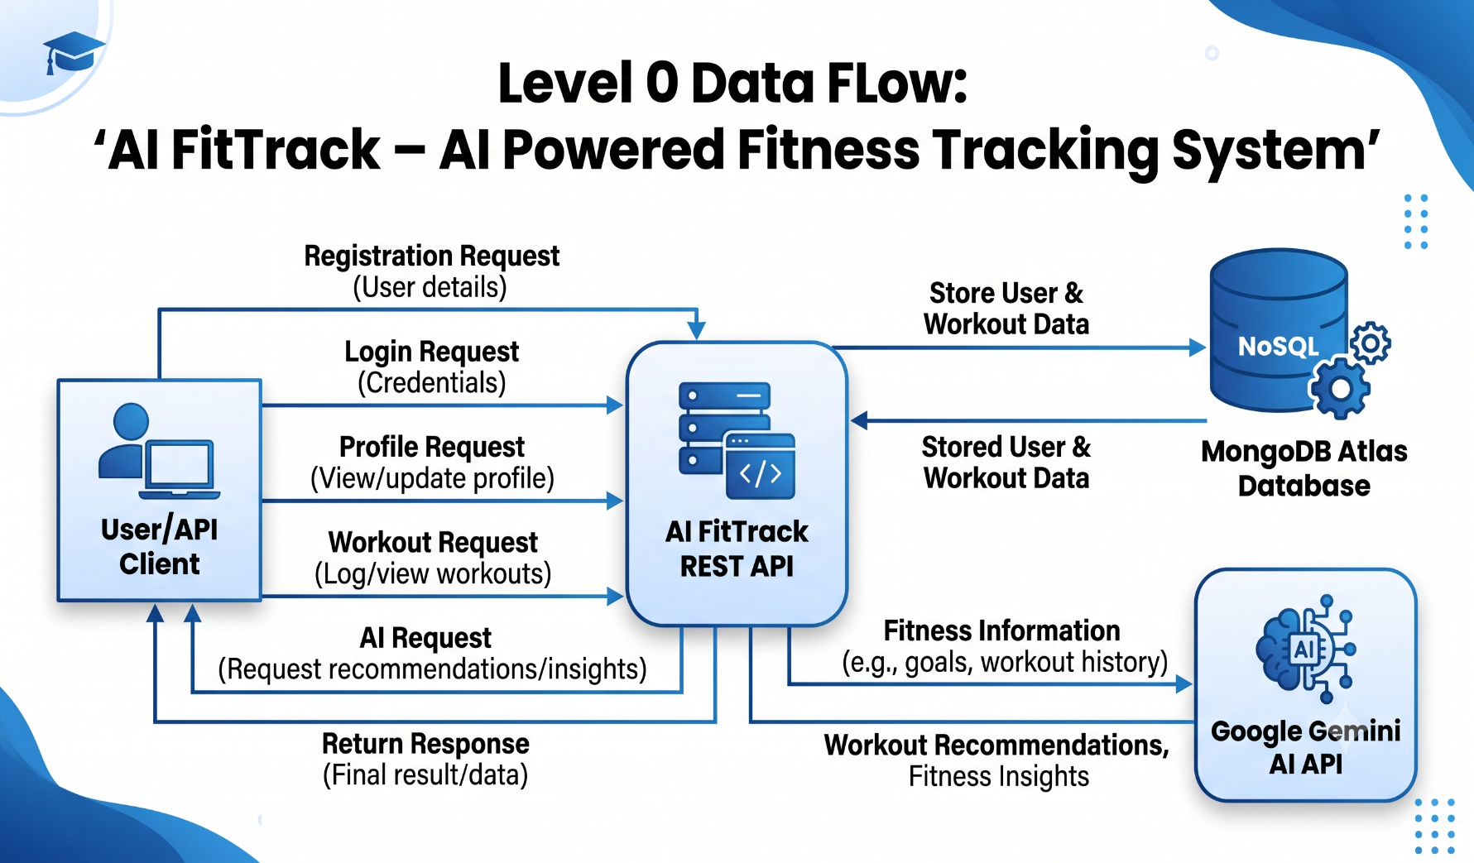

Level 1 – Detailed Data Flow Diagram
The Level 1 DFD divides the AI FitTrack system into its major processes.

Process 1: User Authentication
User → Registration/Login → Authentication Module → MongoDB Atlas
The system validates user information and creates or verifies the user's account. JWT authentication is used for protected requests.

Process 2: Workout Management
User → Workout Details → Workout Management → MongoDB Atlas
The system allows authenticated users to create, view, update, delete, and search workout records.

Process 3: AI Workout Recommendation
User → Age + Fitness Goal + Experience → AI Recommendation Module → Google Gemini AI → Recommendation → User
The system sends the user's fitness information to Google Gemini and returns a personalized workout recommendation.

Process 4: AI Fitness Insights
User → Workout Statistics → AI Insights Module → Google Gemini AI → Fitness Insight → User
The system sends workout statistics such as total workouts, average duration, and total calories burned to Google Gemini and returns a fitness insight.

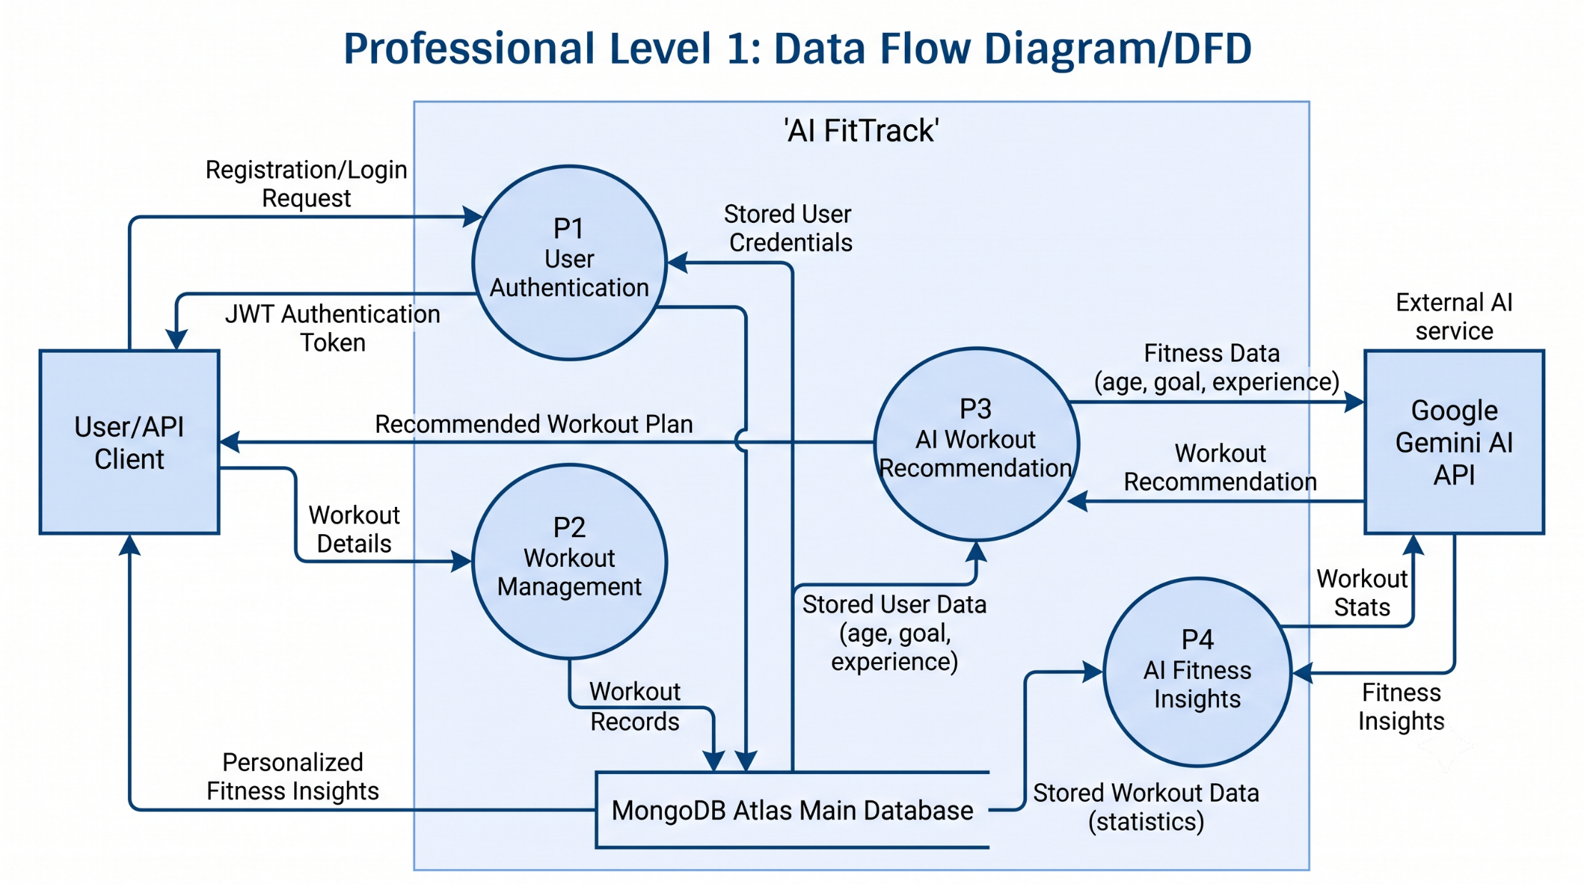

User Stories
The following user stories describe the main functions that users can perform in the AI FitTrack system.
User Type | Functional Requirement (Epic) | User Story Number | User Story / Task | Acceptance Criteria | Priority | Release
Customer / Fitness User | User Registration | USN-1 | As a user, I can register for the application using my name, email, and password. | User account is created successfully when valid details are provided. | High | Sprint-1
Customer / Fitness User | User Authentication | USN-2 | As a user, I can log in using my registered email and password. | User receives a successful login response and authentication token when valid credentials are provided. | High | Sprint-1
Customer / Fitness User | User Profile | USN-3 | As a user, I can view my profile information after authentication. | Authenticated user can retrieve their profile details. | High | Sprint-1
Customer / Fitness User | Workout Management | USN-4 | As a user, I can add a workout record with workout name, category, duration, and calories burned. | A valid workout record is stored successfully in the database. | High | Sprint-1
Customer / Fitness User | Workout Management | USN-5 | As a user, I can view my workout records. | The system returns the user's available workout records. | High | Sprint-1
Customer / Fitness User | Workout Management | USN-6 | As a user, I can update my workout information. | The selected workout record is updated successfully with valid data. | High | Sprint-1
Customer / Fitness User | Workout Management | USN-7 | As a user, I can delete a workout record. | The selected workout record is removed successfully. | Medium | Sprint-1
Customer / Fitness User | Workout Search | USN-8 | As a user, I can search my workout records using a keyword or date-related information. | Matching workout records are returned when a valid search query is provided. | Medium | Sprint-1
Customer / Fitness User | AI Workout Recommendation | USN-9 | As a user, I can receive a personalized workout recommendation based on my age, fitness goal, and experience level. | The system sends valid fitness information to Gemini AI and returns a workout recommendation. | High | Sprint-2
Customer / Fitness User | AI Fitness Insights | USN-10 | As a user, I can receive fitness insights based on my workout statistics. | The system analyzes workout statistics and returns a fitness insight. | High | Sprint-2
Customer / Fitness User | Security | USN-11 | As a user, I can access protected features only after authentication. | Unauthorized requests to protected endpoints are rejected. | High | Sprint-1
Customer / Fitness User | Input Validation | USN-12 | As a user, I receive a clear error message when required information is missing or invalid. | The API returns an appropriate validation error response. | Medium | Sprint-1

User Story Summary
The AI FitTrack user stories focus on four major areas:
- User Management – Registration, login and profile access.
- Workout Management – Create, view, update, delete and search workouts.
- AI Features – Personalized workout recommendations and fitness insights.
- Security & Validation – JWT-based access control and input validation.
These user stories provide the functional foundation for developing and testing the AI FitTrack system.
Project Design Phase-II
Data Flow Diagram & User Stories
Data Flow Diagrams
A Data Flow Diagram (DFD) represents how data moves through the AI FitTrack system. It shows how users interact with the backend, how requests are processed, how data is stored in MongoDB Atlas, and how AI requests are sent to Google Gemini.
Level 0 – Context Diagram
External Entity: User / API Client
Process: AI FitTrack System
Data Store: MongoDB Atlas
External Service: Google Gemini AI
Main Data Flow

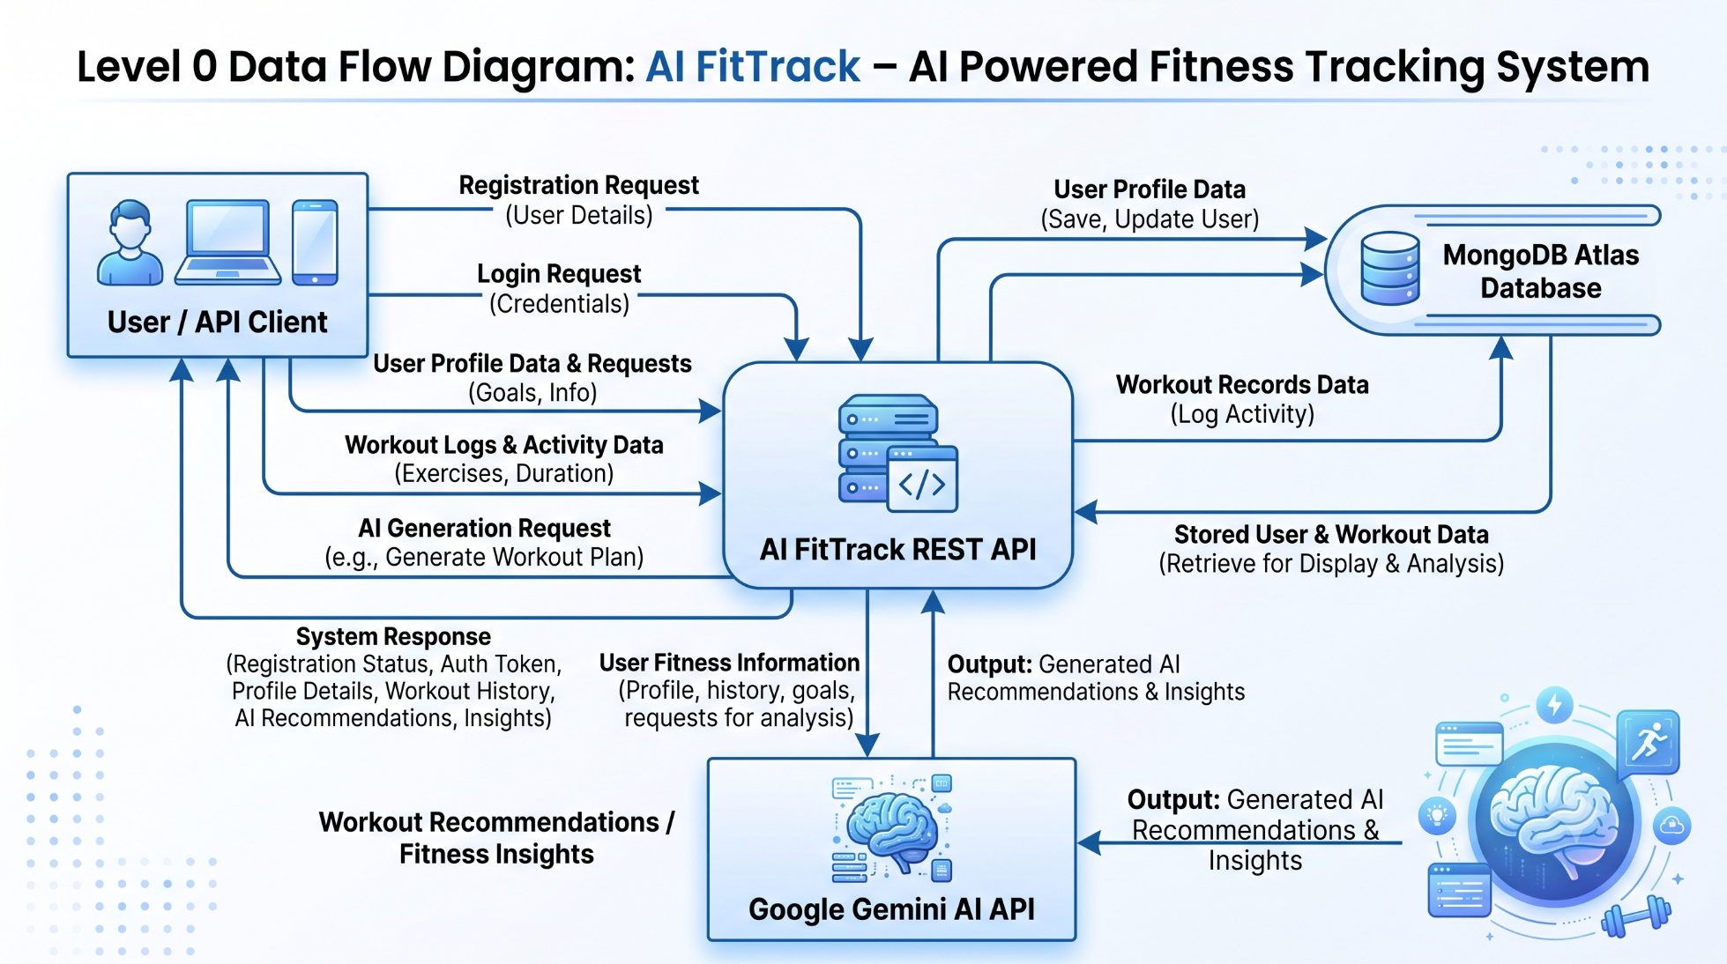

Level 1 – Detailed Data Flow Diagram
The Level 1 DFD divides the AI FitTrack system into its major processes.
Process 1: User Authentication
User → Registration/Login → Authentication Module → MongoDB Atlas
The system validates user information and creates or verifies the user's account. JWT authentication is used for protected requests.
Process 2: Workout Management
User → Workout Details → Workout Management → MongoDB Atlas
The system allows authenticated users to create, view, update, delete, and search workout records.
Process 3: AI Workout Recommendation
User → Age + Fitness Goal + Experience → AI Recommendation Module → Google Gemini AI → Recommendation → User
The system sends the user's fitness information to Google Gemini and returns a personalized workout recommendation.
Process 4: AI Fitness Insights
User → Workout Statistics → AI Insights Module → Google Gemini AI → Fitness Insight → User
The system sends workout statistics such as total workouts, average duration, and total calories burned to Google Gemini and returns a fitness insight.

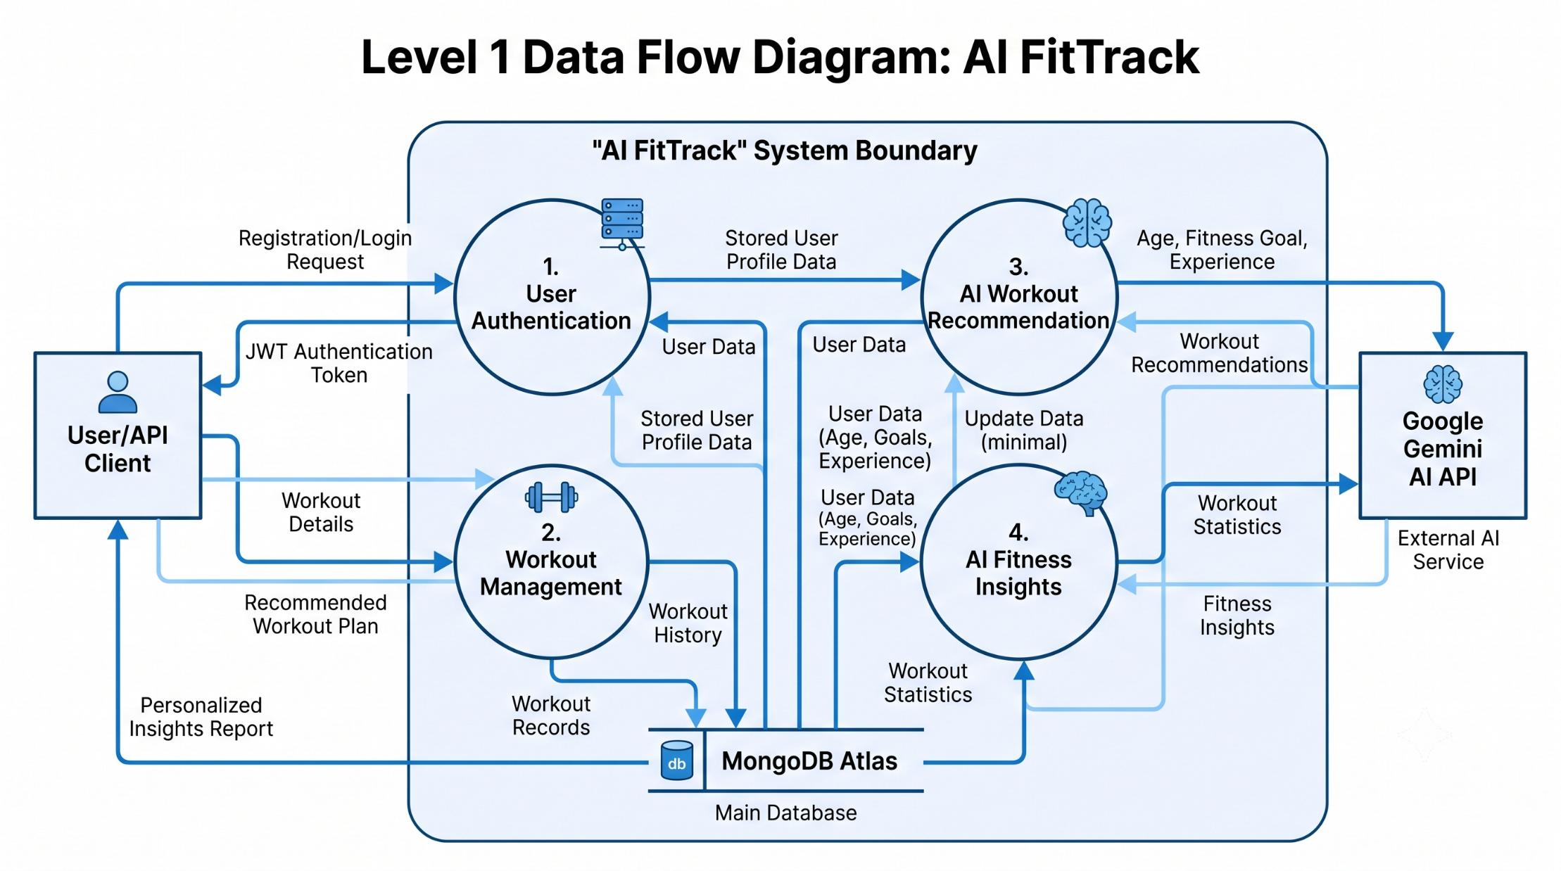

User Stories
The following user stories describe the main functions that users can perform in the AI FitTrack system.
User Type | Functional Requirement (Epic) | User Story Number | User Story / Task | Acceptance Criteria | Priority | Release
Customer / Fitness User | User Registration | USN-1 | As a user, I can register for the application using my name, email, and password. | User account is created successfully when valid details are provided. | High | Sprint-1
Customer / Fitness User | User Authentication | USN-2 | As a user, I can log in using my registered email and password. | User receives a successful login response and authentication token when valid credentials are provided. | High | Sprint-1
Customer / Fitness User | User Profile | USN-3 | As a user, I can view my profile information after authentication. | Authenticated user can retrieve their profile details. | High | Sprint-1
Customer / Fitness User | Workout Management | USN-4 | As a user, I can add a workout record with workout name, category, duration, and calories burned. | A valid workout record is stored successfully in the database. | High | Sprint-1
Customer / Fitness User | Workout Management | USN-5 | As a user, I can view my workout records. | The system returns the user's available workout records. | High | Sprint-1
Customer / Fitness User | Workout Management | USN-6 | As a user, I can update my workout information. | The selected workout record is updated successfully with valid data. | High | Sprint-1
Customer / Fitness User | Workout Management | USN-7 | As a user, I can delete a workout record. | The selected workout record is removed successfully. | Medium | Sprint-1
Customer / Fitness User | Workout Search | USN-8 | As a user, I can search my workout records using a keyword or date-related information. | Matching workout records are returned when a valid search query is provided. | Medium | Sprint-1
Customer / Fitness User | AI Workout Recommendation | USN-9 | As a user, I can receive a personalized workout recommendation based on my age, fitness goal, and experience level. | The system sends valid fitness information to Gemini AI and returns a workout recommendation. | High | Sprint-2
Customer / Fitness User | AI Fitness Insights | USN-10 | As a user, I can receive fitness insights based on my workout statistics. | The system analyzes workout statistics and returns a fitness insight. | High | Sprint-2
Customer / Fitness User | Security | USN-11 | As a user, I can access protected features only after authentication. | Unauthorized requests to protected endpoints are rejected. | High | Sprint-1
Customer / Fitness User | Input Validation | USN-12 | As a user, I receive a clear error message when required information is missing or invalid. | The API returns an appropriate validation error response. | Medium | Sprint-1
User Story Summary
The AI FitTrack user stories focus on four major areas:
- User Management – Registration, login and profile access.
- Workout Management – Create, view, update, delete and search workouts.
- AI Features – Personalized workout recommendations and fitness insights.
- Security & Validation – JWT-based access control and input validation.
These user stories provide the functional foundation for developing and testing the AI FitTrack system.

